H.T No
Regulations:
A22

Sreenidhi Institute of Science and Technology
(An Autonomous Institution)
Code No: 9AC48 Date: 18-Feb-2025 (FN)

B.Tech I-Year II- Semester External Examination, February-2025 (Supplementary)
BASIC ELECTRICAL AND ELECTRONICS ENGINEERING (CSE, IT, DS, CS, AIML and IOT)

Time: 3 Hours Max.Marks:60

Note: a) No additional answer sheets will be provided.
b) All sub-parts of a question must be answered at one place only, otherwise it will not be valued.
c) Missing data can be assumed suitably.
Bloom's Cognitive Levels of Learning (BCLL)

Remember | L1 | Apply | L3 | Evaluate | L5
Understand | L2 | Analyze | L4 | Create | L6

Part - A Max.Marks: 6x2=12

Answer all QUESTIONS, EACH QUESTION CARRIES 2 MARKS.

 |  | BCLL | CO(s) | Marks
1 | List the limitations of Ohm’s law . | L1 | CO1 | [2M]
2 | Compute the phase angle between i₁ = - 4 sin(377t + 25⁰) and i₂ = 5 cos(377t - 40⁰) and Does i₁ lead or lag i₂? | L2 | CO2 | [2M]
3 | What do you mean by Integrating instruments ? | L1 | CO3 | [2M]
4 | Write the applications of p-n Diode ? | L1 | CO4 | [2M]
5 | Differentiate between NPN and PNP transistors. | L2 | CO5 | [2M]
6 | Write the possible digit symbols used in hexa decimal system? | L1 | CO6 | [2M]

Part – B Max.Marks: 6x8=48
ANSWER ALL QUESTIONS. EACH QUESTION CARRIES 8 MARKS.

 |  | BCLL | CO(s) | Marks
7. | i) State Kirchhoff’s Laws.  ii) Determine the Voltages V₁ and V₂ in the circuit shown below?  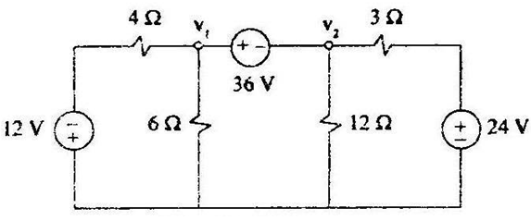 | L2  L3 | CO1 | [8M]
 | OR
8 | i) Derive an expression for induced emf equation of DC generator.  ii)A 250 V dc shunt motor takes 36A from supply for its operation at full load. The resistances of armature and field windings of motor are 0.1 ohm and 250 ohm respectively. Calculate the back emf on full load of the motor | L2  L3 | CO1 | [8M]
9. | i)Define rms value and average value for an alternating quantities .  ii)A series R-C series circuit with R=20 ohm and C =127 micro Farad fed from 160V,50Hz Supply. Calculate the current ,power factor and power consumed of the circuit. | L2  L3 | CO2 | [8M]
 | OR
10 | i)List the advantages of Poly phase systems over Single phase systems.  ii)Each phase of three phase generator produces a voltage of 3810 Volts and carries a maximum current of 300 A . Determine the line currents, line voltages and total Capacity ,if the generator is delta connected . | L2  L3 | CO2 | [8M]
11 | Explain the construction and operation of three phase induction motor. | L2 | CO3 | [8M]
 | OR
12 | Explain the construction and working of Permanent magnet moving coil instrument with neat sketch. | L2 | CO3 | [8M]
13 | With the help of V-I characteristics, explain pn diode operation. | L2 | CO4 | [8M]
 | OR
14 | Explain the operation of Full wave bridge rectifier with relevant wave forms | L2 | CO4 | [8M]
15 | Explain the input and output characteristics of the transistor in Common Base configuration with diagrams. | L2 | CO5 | [8M]
 | OR
16 | Explain the constructional features of a depletion mode P-channel and Enhancement mode MOSFET and explain its basic operation. | L2 | CO5 | [8M]
17 | i)State and prove De Morgan theorems  ii)Reduce the following expression using Karnaugh map . | L2  L3 | CO6 | [8M]
 | OR
18 | Realize basic gates using NAND only | L3 | CO6 | [8M]

-- 00 -- 00 –

